

# Blogg

Mobile Application

user guide

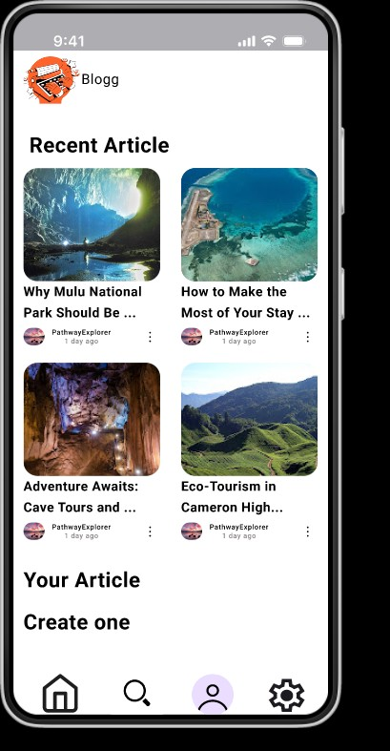

## Touriest destination blog

Main page

## Blogg

view the article uploaded by blogger

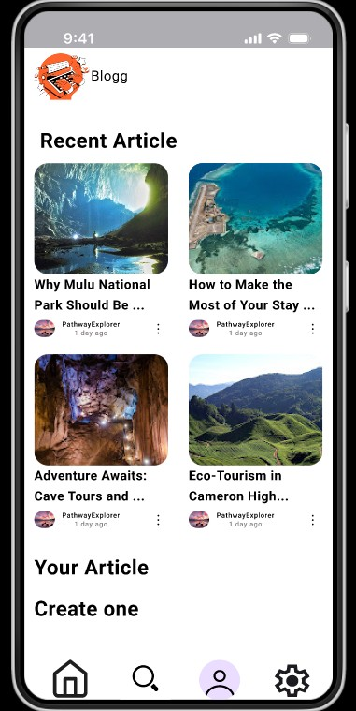

View the blogger who uploaded this article

The app settings

Home button

search bar

User profile

Settings

## Blogg



The Article Title

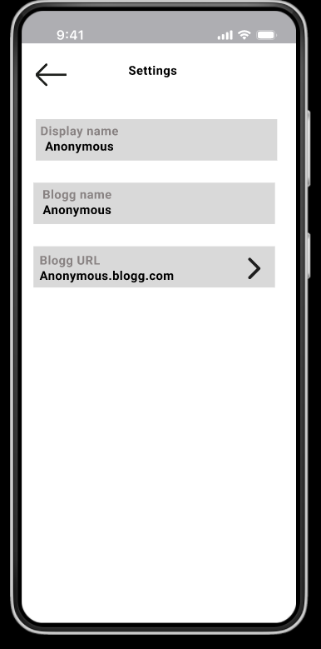

User name

The Article link

User profile

## Blogg

Username

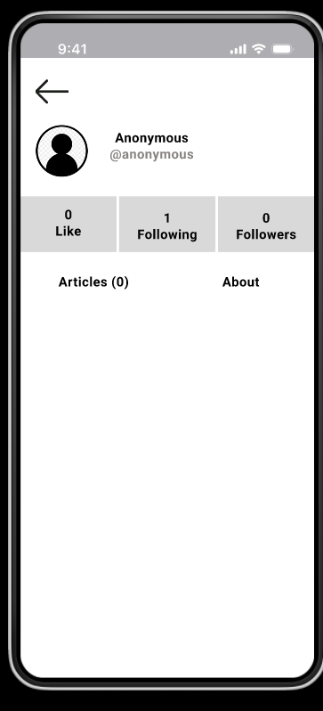

Following Folllowers

Like

Article uploded by the user

User’s Biography

Blogger profile

## Blogg

Blogger’s Username

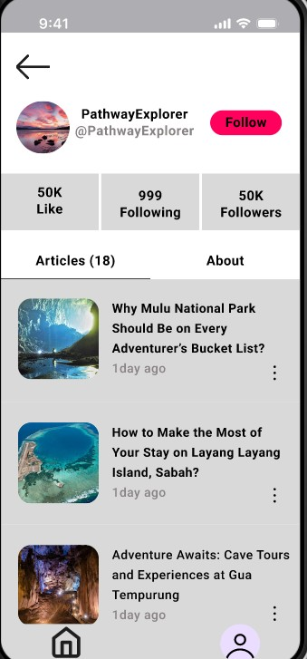

Folllowers

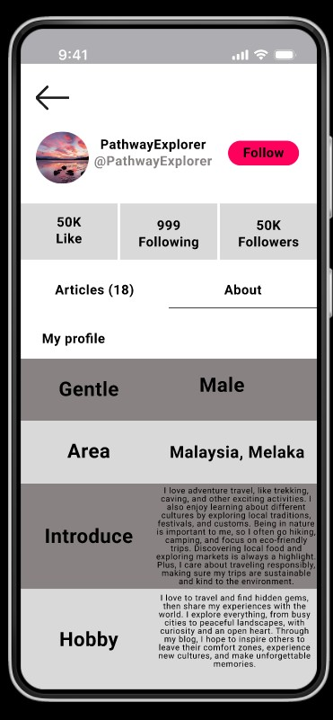

Blogger biography

Like

Following



Article uploaded by the blogger

Article sample

## Blogg



Article Title

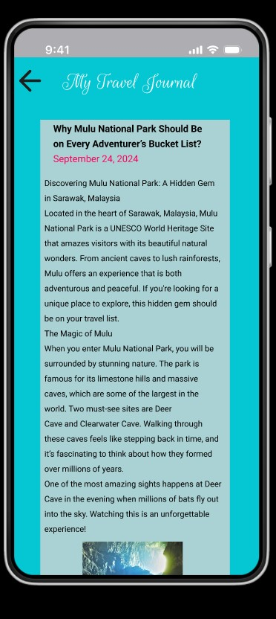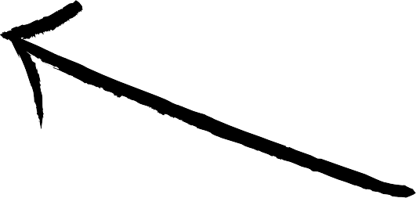

Article uploaded date

The content



## Blogg

Thats all from us Have fun using our App